Lower Hemisphere
# Source: AI Source: Provided by: [Data Path: Persons Table -> ID Column: 1, Name_En Column: Motasem Essam] -> From: [ChatGPT] on [7/25/2026]
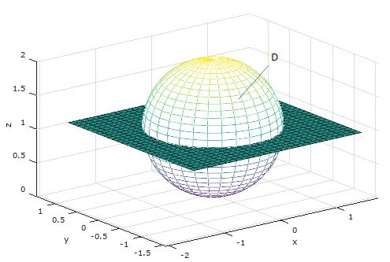

Definition
# Source: AI Source: Provided by: [Data Path: Persons Table -> ID Column: 1, Name_En Column: Motasem Essam] -> From: [ChatGPT] on [7/25/2026]
A lower hemisphere is the lower half of a sphere formed when a plane passing through the sphere's center divides it into two equal halves. In the standard Cartesian coordinate system, it is the half lying below the $xy$-plane, where $z≤0$.
The solid lower hemisphere consists of the curved spherical surface and the flat circular base.

Simple Definition
# Source: AI Source: Provided by: [Data Path: Persons Table -> ID Column: 1, Name_En Column: Motasem Essam] -> From: [ChatGPT] on [7/25/2026]
The lower hemisphere is the bottom half of a sphere, separated from the upper half by a flat plane through the sphere's center.
For a sphere centered at the origin, it is the portion below the $xy$-plane.

Geometric Representation
# Source: AI Source: Provided by: [Data Path: Persons Table -> ID Column: 1, Name_En Column: Motasem Essam] -> From: [ChatGPT] on [7/25/2026]
Consider a sphere with center $O=\left(0,0,0\right)$ and radius $R$. The $xy$-plane divides the sphere into an upper hemisphere and a lower hemisphere.
- Center: $O=\left(0,0,0\right)$
- Radius: $R$
- Dividing plane: $z=0$, the $xy$-plane
- Lower hemisphere: the portion satisfying $z≤0$
- Base: a circular disk of radius $R$ in the plane $z=0$
The lower hemisphere includes its circular boundary along the equator. The curved surface alone does not include the flat base.

Mathematical Representation
# Source: AI Source: Provided by: [Data Path: Persons Table -> ID Column: 1, Name_En Column: Motasem Essam] -> From: [ChatGPT] on [7/25/2026]
The equation of the full sphere centered at the origin is
$$x^{2}+y^{2}+z^{2}=R^{2}$$
The solid lower hemisphere is defined by
$$\boxed{x^{2}+y^{2}+z^{2}≤R^{2}, z≤0}$$
Its curved surface satisfies
$$x^{2}+y^{2}+z^{2}=R^{2}, z≤0$$
Its flat circular base satisfies
$$x^{2}+y^{2}≤R^{2}, z=0$$

6. Formulas
# Source: AI Source: Provided by: [Data Path: Persons Table -> ID Column: 1, Name_En Column: Motasem Essam] -> From: [ChatGPT] on [7/25/2026]
Let $R$ represent the radius of the sphere.
Volume of the solid lower hemisphere
$$V=\frac{2}{3}πR^{3}$$
Curved surface area
$$A_{c}=2πR^{2}$$
Flat circular base area
$$A_{b}=πR^{2}$$
Total surface area, including the base
$$A_{T}=3πR^{2}$$

Key Characteristics
# Source: AI Source: Provided by: [Data Path: Persons Table -> ID Column: 1, Name_En Column: Motasem Essam] -> From: [ChatGPT] on [7/25/2026]
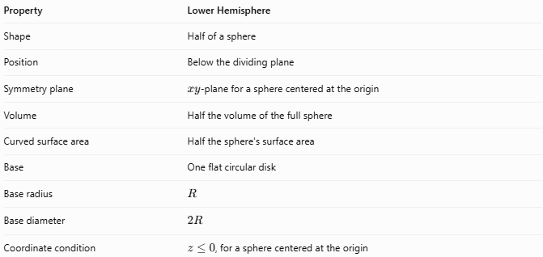
Property | Lower Hemisphere
Shape | Half of a sphere
Position | Below the dividing plane
Symmetry plane | $xy$-plane for a sphere centered at the origin
Volume | Half the volume of the full sphere
Curved surface area | Half the sphere's surface area
Base | One flat circular disk
Base radius | $$R$$
Base diameter | $$2R$$
Coordinate condition | $z≤0$, for a sphere centered at the origin

Worked Example
# Source: AI Source: Provided by: [Data Path: Persons Table -> ID Column: 1, Name_En Column: Motasem Essam] -> From: [ChatGPT] on [7/25/2026]
Problem: A sphere has a radius of $5\text{ cm}$. Find the volume, curved surface area, and total surface area of its lower hemisphere.
Given:
$$R=5\text{ cm}$$
Step 1 — Volume
$$V=\frac{2}{3}πR^{3}=\frac{2}{3}π{\left(5\right)}^{3}$$
$$\boxed{V=\frac{250π}{3}{\text{ cm}}^{3}≈261.80{\text{ cm}}^{3}}$$
Step 2 — Curved surface area
$$A_{c}=2πR^{2}=2π{\left(5\right)}^{2}$$
$$\boxed{A_{c}=50π{\text{ cm}}^{2}≈157.08{\text{ cm}}^{2}}$$
Step 3 — Total surface area
$$A_{T}=3πR^{2}=3π{\left(5\right)}^{2}$$
$$\boxed{A_{T}=75π{\text{ cm}}^{2}≈235.62{\text{ cm}}^{2}}$$

Lower Hemisphere vs. Upper Hemisphere
# Source: AI Source: Provided by: [Data Path: Persons Table -> ID Column: 1, Name_En Column: Motasem Essam] -> From: [ChatGPT] on [7/25/2026]
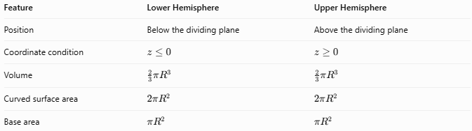
Feature | Lower Hemisphere | Upper Hemisphere
Position | Below the dividing plane | Above the dividing plane
Coordinate condition | $$z≤0$$ | $$z≥0$$
Volume | $$\frac{2}{3}πR^{3}$$ | $$\frac{2}{3}πR^{3}$$
Curved surface area | $$2πR^{2}$$ | $$2πR^{2}$$
Base area | $$πR^{2}$$ | $$πR^{2}$$
Both hemispheres have equal volumes and surface areas when they have the same radius. Their names depend on the selected orientation and dividing plane.

Applications
# Source: AI Source: Provided by: [Data Path: Persons Table -> ID Column: 1, Name_En Column: Motasem Essam] -> From: [ChatGPT] on [7/25/2026]
- Mathematics: Studying spherical regions and three-dimensional coordinate inequalities.
- Architecture: Modeling downward-facing hemispherical structures and dome components.
- Engineering: Designing hemispherical housings and curved components.
- Physics: Representing lower spherical regions in spatial models.
- Computer graphics: Defining and rendering the bottom half of a sphere.

Key Points
# Source: AI Source: Provided by: [Data Path: Persons Table -> ID Column: 1, Name_En Column: Motasem Essam] -> From: [ChatGPT] on [7/25/2026]
- A lower hemisphere is the bottom half of a sphere divided by a plane through its center.
- For a sphere centered at the origin, the standard lower hemisphere satisfies $z≤0$.
- Its volume is $\frac{2}{3}{πR}^{3}$.
- Its curved surface area is $2πR^{2}$.
- Its total surface area, including the base, is $3πR^{2}$.
- It consists of a curved spherical surface and a flat circular base.

Conclusion
# Source: AI Source: Provided by: [Data Path: Persons Table -> ID Column: 1, Name_En Column: Motasem Essam] -> From: [ChatGPT] on [7/25/2026]
The lower hemisphere is one of the two equal halves of a sphere, lying below a plane through its center in the standard orientation. It has half the volume of the full sphere, half its curved surface area, and one flat circular base. Its geometric properties are identical to those of the upper hemisphere; only its position differs.

